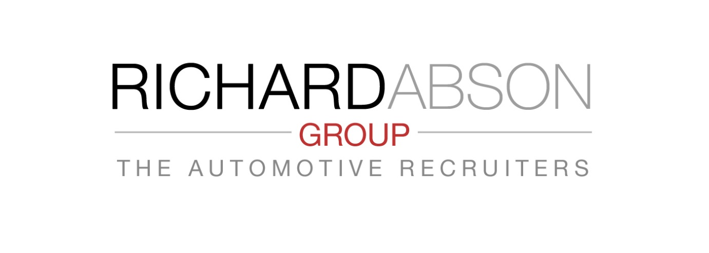Key Elements of a Thorough Recruiting Process

Part 3 - Colleague & Team Approval
Whoever you employ, they are each likely to be involved with a Team of associated colleagues, e.g. one of Technicians, or one of the Sales Team. Those teams also have to relate and interact with other teams, or managers thereof.
• How many new recruits are appointed having met just one or two interviewers / decision makers, without regard to the people that the new recruit will be only introduced to
AFTER the appointment commencement day?
• How many times may you have heard that, after starting a job, the new candidate is not totally accepted by work colleagues, or a manager who has not been involved with the interview?
Formal relationships and social relationships are not mutually exclusive in the workplace. They have to be recognised. Consider – everyone works closer and more hours together than with a family in home life (sadly). For best overall efficiency, all people have to respect the need to get on with each other, with some genuine personal chemical interaction.
Most importantly, it is unreasonable for a new employee to be engaged before and introduction to his immediate manager and work colleagues – if they do not like each other, the candidate will not last too long, and / or performance will suffer.
Last month, we discussed the Interview Process – the more interviews the better. This allows both parties to get to know each other, and exchange questions and information towards a better understood decision.
Now let’s go one stage further - Introduce Candidates to any direct Managers (who may not have been involved with the interview process thus far). Also introduce short listed or chosen candidate to immediate Team colleagues, with whom he/she will be closely working.
Do this prior to a final decision of appointment, and take into account any feedback the work colleagues may have. This process is of greater importance than most decision makers consider and for many implications!

The Automotive Recruiters
Tel : 01829 730116 Email : info@the-AMR.com

